5.125: Take all accelerations to be positive downward. The equations of motion are straightforward, but the kinematic relations between the accelerations, and the resultant algebra, are not immediately obvious. If the acceleration of pulley B is 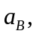 then 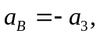 and 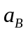 is the average of the accelerations of masses 1 and 2, or 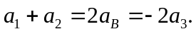 There can be no net force on the massless pulley B, so 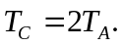 The five equations to be solved are then
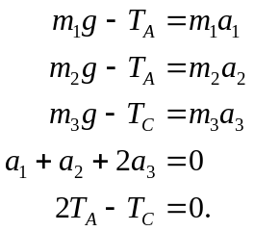
These are five equations in five unknowns, and may be solved by standard means. A symbolic-manipulation program is of great use here.
a) The accelerations  and  may be eliminated by using
The tension 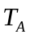 may be eliminated by using
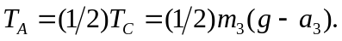
Combining and solving for 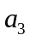 gives
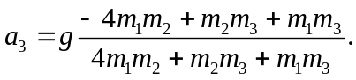
b) The acceleration of the pulley B has the same magnitude as and is in the opposite direction.
c) 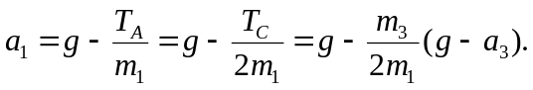
Substituting the above expression for gives
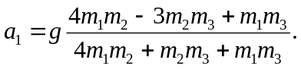
d) A similar analysis (or, interchanging the labels 1 and 2) gives
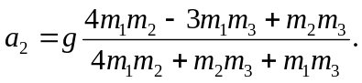
e) & f) Once the accelerations are known, the tensions may be found by substitution into the appropriate equation of motion, giving
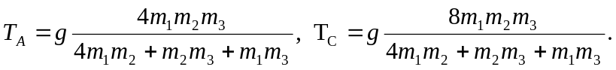
g) If 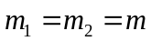 and 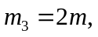 all of the accelerations are zero, 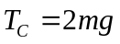 and 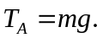 All masses and pulleys are in equilibrium, and the tensions are equal to the weights they support, which is what is expected.

